Karrlem Lewis

Prof. Roberts

MMP 350

February 1st, 2016

The site that I will be choosing is IGN.com

* I like the color scheme of their logo/site, I think that white and red go well together.



* I like their navigation bar, not including the advertisement.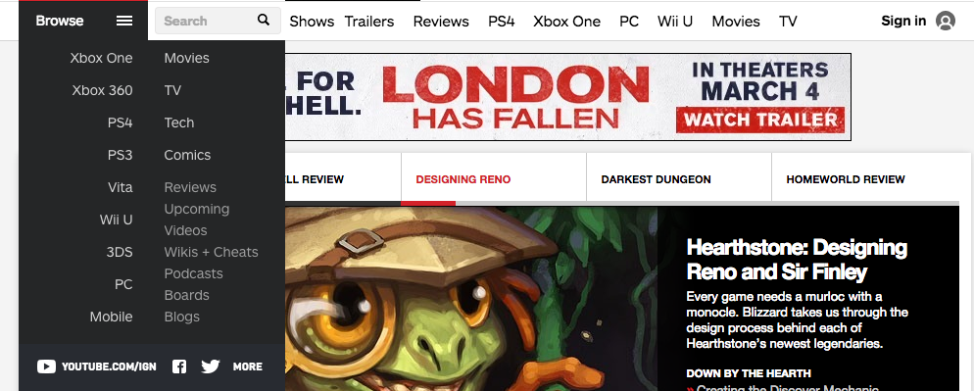
* The dividers and sections are really good and the location they put it makes sense.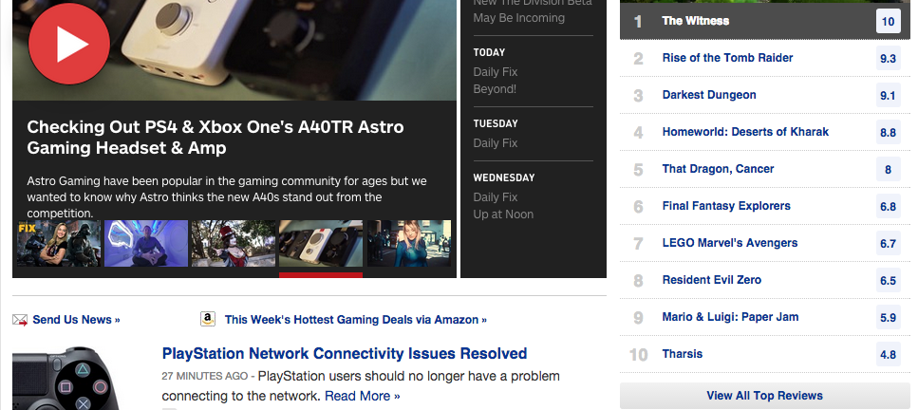
* The news section a simple but nice design to it. There is a neat dropdown that allow for you to view previous missed news.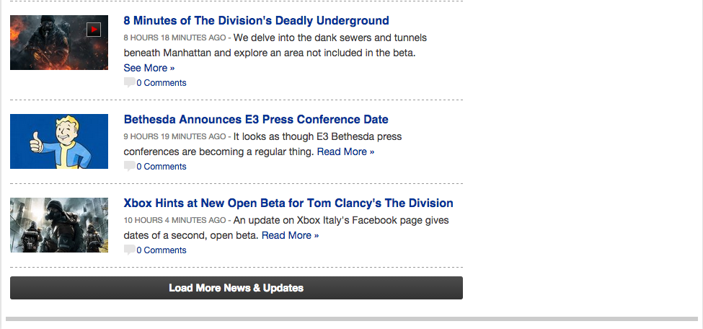
* The carousel is very nicely designed, it has a nice design, timer and has links within it.
* I don’t like how there is a lot of empty unused spots, but the center makes up for the design, and the mac screen is really big.
* I don’t like that the site isn’t really responsive and it only cater to pc users .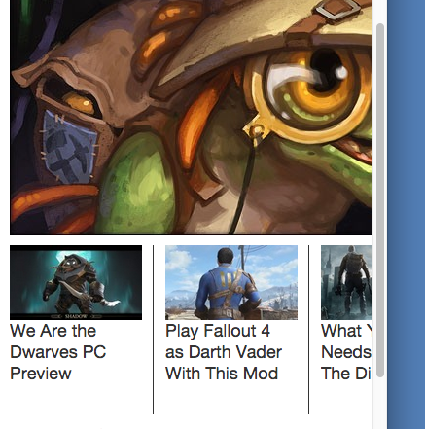
* I don’t like the footer’s design, it looks unfinished and the font is too small.
* I feel that with all the extra space , they could have made the content a little larger.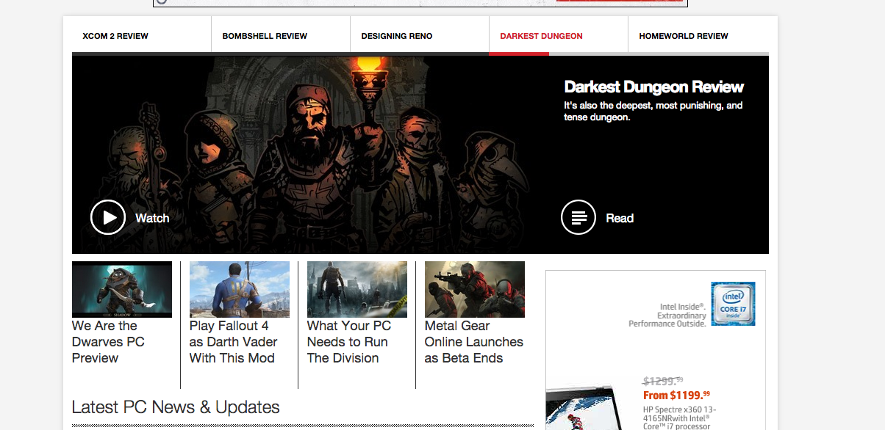
* Just like the footer the header looks unfinished 